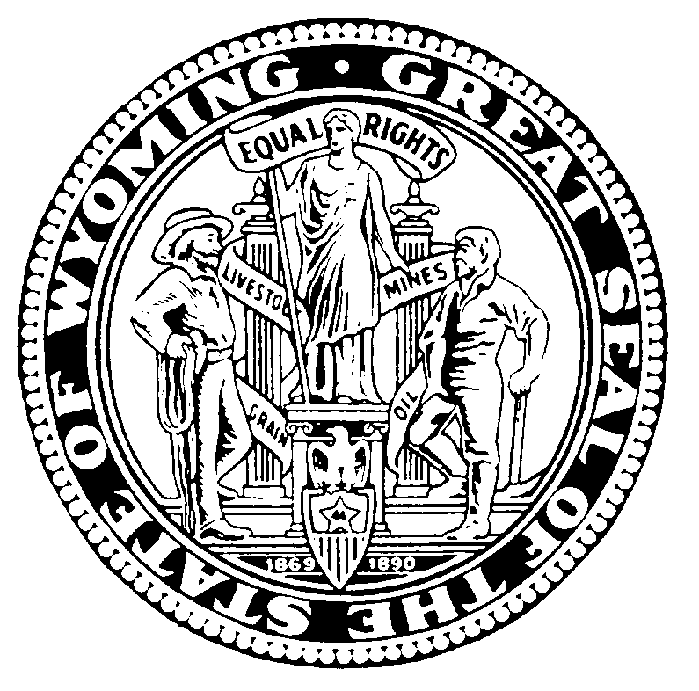  Matthew H. Mead  Governor | Wyoming Livestock Board  "Safeguarding Wyoming’s Livestock Industry Today and for the Future"  1934 Wyott Drive, Cheyenne, Wyoming 82002-0051  Phone: (307) 777-7515 Fax: (307) 777-6561 Web Site: http://wlsb.state.wy.us  Jim Logan, DVM - State Veterinarian | Leanne Correll  Director-Chief Executive Officer
Memorandum

To: Wyoming County Fairs, Wyoming Extension Offices, Wyoming State Fair,
Wyoming Department of Agriculture

From: Dr. Jim Logan, State Veterinarian

Date: March 18, 2013

Ref: 13-SID-0301

Subject: Scrapie Identification Requirements for Sheep and Goats Being Exhibited at Wyoming Fairs and Jackpots

=================================================================
Sheep and goat exhibitors at Wyoming jackpots, county fairs, and state fair are reminded of the Wyoming Livestock Board (WLSB) and APHIS requirements that ALL sheep and goats exhibited in Wyoming MUST be individually identified with USDA-APHIS approved Scrapie identification. This requirement includes wethers. A USDA Scrapie tag must be in the ear of all exhibition sheep and goats. Scrapie identification should be traceable to the premise of origin (where the animal was born) through ownership records.

The ONLY exception to the tag requirement is that registered animals may be identified with a legible registration tattoo and must be accompanied with their registration papers.

The state requirement is consistent with the federal USDA-APHIS Scrapie identification requirement. WLSB and USDA-APHIS personnel will be checking for compliance with this requirement at county and state fairs. To avoid enforcement action, exhibitors are urged to be in compliance by having their sheep and goats properly identified PRIOR to arriving at the fair.

Questions may be directed to:
Dr. Jim Logan, Wyoming State Veterinarian – Phone: (307) 857-4140, email: jim.logan@wyo.gov
Dr. Bob Meyer, WY Assistant State Veterinarian – Phone (307) 777-7515, email: bob.meyer@wyo.gov
Dr. John Duncan, USDA-APHIS VMO – Phone: (307) 351-8387, email: john.v.duncan@aphis.usda.gov
Dr. Barbara Kizer, USDA-APHIS VMO – Phone: (307) 334-2107 or (307) 575-3261
email: barbara.m.kizer@aphis.usda.gov
Dr. Rick Riesland, USDA-APHIS VMO – Phone: (307) 214-5121, email: rick.riesland@aphis.usda.gov
Mr. Danny Cosner, USDA-APHIS ID Coordinator – Phone: (307) 217-0275
email: danny.j.cosner@aphis.usda.gov

(over)

Page 2
Scrapie Identification Requirements for Sheep and Goats Being Exhibited at Wyoming Fairs and
Jackpots
March 18, 2013

The Wyoming Livestock Board Chapter 13 Scrapie Rules can be found online at: http://soswy.state.wy.us/Rules/RULES/6024.pdf Please see Section 6(b)(ii).

The USDA-APHIS Scrapie Rules can be found online at: http://www.aphis.usda.gov/animal_health/animal_diseases/scrapie/downloads/umr_scrapie.pdf Please see Parts III and IV.

Cc: WLSB Director-CEO
WLSB Animal Health Personnel
WLSB Law Enforcement Personnel
WLSB Brand Inspectors
USDA-APHIS-AVIC

